UNIVERSITY OF MINNESOTA

Duluth Campus Department of Studies in Justice, Culture, and Social Change 228 Cina Hall
College of Arts, Humanities, and Social Sciences 1123 University Drive
Duluth, Minnesota 55812-3306
E-mail: troufs@d.umn.edu
ZOOM: ​ttps://umn.zoom.us/my/troufs
6 October 2024


f2024 Week 7 Module

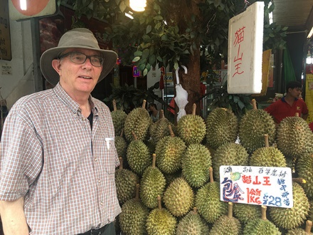

Tim Roufs, Singapore Market, 2017

Anthropology of Europe Week 7

What’s Happening Week 7?

        - READ AND WATCH
          - READ TEXT . . .
          - VIEW SLIDES
          - WATCH VIDEO
            - Watch Video Clips
          - IN-THE-NEWS
        - MIDTERM EXAM
        - DISCUSSION
        - PROJECT
        - OTHER
            - EXTRA CREDIT
            - FOR FUN TRIVIA (optional)
            - LIVE CHAT (optional)
Tuesday 7:00-8:00 p.m.
        - QUESTIONS / COMMENTS / SUGGESTIONS
        - WRAP-UP
[click ↑ here]

What’s Happening Week 7?

One big event of the week is the Midterm Exam which will be available this week from 12:01 a.m. Monday, 7 October 2024 to 11:59 Saturday, 12 October 2024.

After the exam we’re headed off to Turkey where we’ll meet Elif, a 12-year-old Turkish girl, who will tell us about her Sufi spiritual journey, up-until-so-far. Elif is part of the Mevlevi Brotherhood, known as “Whirling Dervishes” in the Western world. They are a part of Sufi/Mystic traditional Islam.

Turkey is a transcontinental country having 3.02% of its land in Europe, with the remainder in Asia. As Turkey overall is the thirty-eighth largest country in the world in land mass (302,535 mi²), the part of Turkey that is geographically in Europe (9,175 mi²) is larger than thirteen other European countries. For example, all of Slovenia (7,827 mi²) is smaller than just the European lands of Turkey.

And speaking of Turkey and the Middle East, we’ll finish off our adventures of the week having a three-minute look at 5,000 years of the Imperial history of the Middle East—which generally and importantly very much included parts of Europe.

After all of that, it’s back to your Class Project, to finish your Project Abstract and Working Bibliography which are due by Saturday evening.

Read and Watch Week 7

READ THE TEXTBOOK FOR WEEK 7
Textbook Information
Readings for the Semester

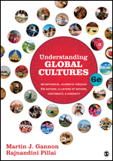

REM: Links on screenshots are not “hot” (active)
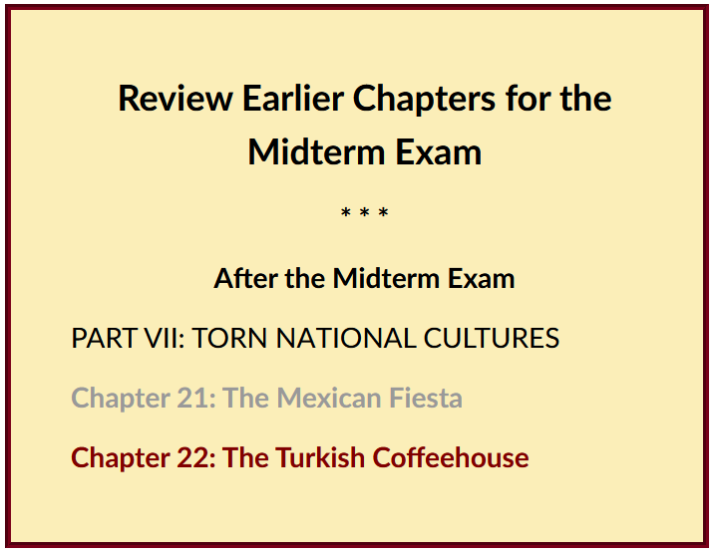

VIEW THE SLIDES FOR WEEK 7
Class Slides for the Semester

If you haven’t already done so, before the exam be sure to finish
“Master Texts and Classics”
(.pptx)
[click ↑ here]

A “Master Text” is a work (video or print item or research technique or theoretical approach) that helped set the stage for what came later and which in one or more ways influenced the development of a discipline or sub-discipline. Kypseli, for e.g., is one. Ernestine Friedl’s Vasilika, for e.g., is another one.

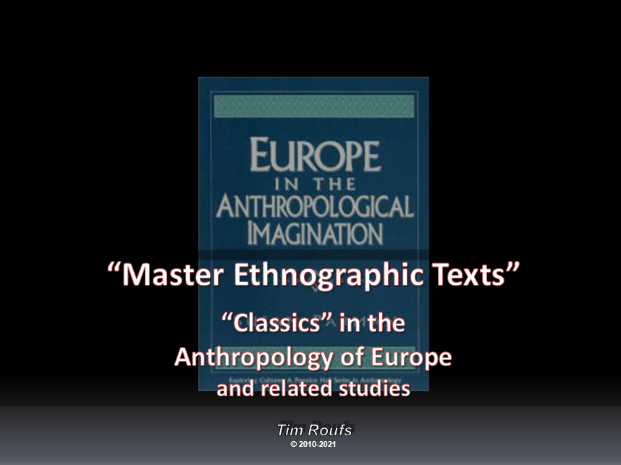

After you take the Midterm exam re-view . . .
“Main Characteristics of Anthropology”
(.pptx)
[click ↑ here]

WATCH THE VIDEO EXPLORATIONS FOR WEEK 7
Real People . . . Real Places . . .
Videos for the Semester

I Named Her Angel
[Turkey]
(29 min., 2008)

On-line Link
[click ↑ here]

course viewing guide

Terms -- Religion: Ritual / Doctrine

Terms -- Education / Enculturation

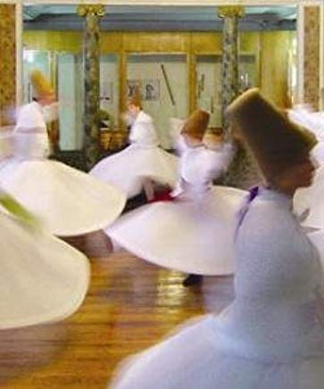

WATCH THE VIDEO CLIPS FOR WEEK 7

Watch Video Clip
Class Slides for the Semester

IN-THE-NEWS WEEK 7
Media Bias Chart
Fake News

Sign Up in your Course Google Drive Folder:
f2024 <https://docs.google.com/document/d/1IlkUMRHy7ZPeIbxYelRuFGw4Vc5ZwXwv1e-qKEgDDvk/edit?usp=sharing>
[click ↑ here]

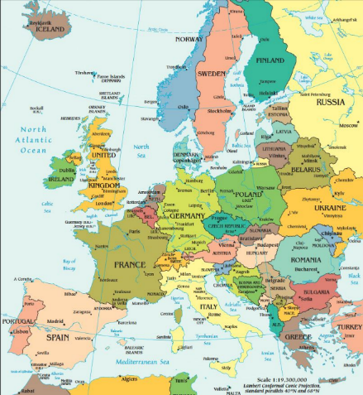

Türkiye (fka Turkey)

MIDTERM EXAM . . .
General Midterm Exam Information

The Midterm Exam This Week . . .
will be available from Monday a.m. to Saturday,
7 - 12 oCTOBER 2024
(10:00 p.m. starting time on Saturday)

Study Questions are at . . .
f2024 <https://canvas.umn.edu/courses/450740/modules/items/12194387>
[click ↑ here]

General Midterm Exam Information is at . . .
<https://www.d.umn.edu/cla/faculty/troufs/anth3635/ceexams_midterm.html#title>

REM: Live Chat is Tuesday at 7:00 pm

Before the Exam review these slide presentations
we have seen so far in class.
They include . . .

“Introduction / Orientation”
(.pptx)
[click ↑ here]

“Main Characteristics of Anthropology”
(.pptx)
[click ↑ here]

"Other Important Terms"
(.pptx)
[click ↑ here]

“Holism”
(.pptx)
[click ↑ here]

"Master Texts" and Classics
(.pptx)
[click ↑ here]

DISCUSSION FOR WEEK 7
Online Discussions Information, Rubric, and Sample Posts

Master Texts and 'Classics" in Anthropology and in Your Major

PROJECT INFORMATION . . .
Basic Information
Main Due Dates

REM: Your Project Abstract and Working Bibliography is Due this Week
REM: Links on screenshots are not “hot” (active)

"Abstracts"
Maxine C. Hairston¹
The Uses of Abstracts
Writing the Abstract
Length of Abstracts

What you will be doing for your paper is
a "Promissory Abstract"

- Promissory Abstracts
  - Writing the Promissory Abstract
  - Length of Abstracts
- Summary Abstracts
  - Writing the Summary Abstract
  - Length of Abstracts
see also

Writing Report Abstracts
<http://owl.english.purdue.edu/owl/resource/656/01/>
Abstracts and Executive Summaries
<http://owl.english.purdue.edu/owl/resource/726/07/>
Journal Abstracts
<http://owl.english.purdue.edu/owl/resource/752/04/>

OTHER . . .
Main Due Dates

f2024 Module 7 - Week 7

“Imperial History of the Middle East:
5000 Years of History in 90 seconds”
(Actually, 3 min.)
[click ↑ here]

A Brief Review of
Turkey and the Ottoman Empire

Moors and other Arab Influences, A.D. 711 - A.D. 1492
Ottoman Influences A.D. 1517 –

Thursday we’ll have a quick look at (literally) “Imperial History of the Middle East: 5000 Years of History in 90 seconds.” It’s short—135 seconds (things are not always as advertised). Pay special attention to what is happening within the borders of modern-day Europe.

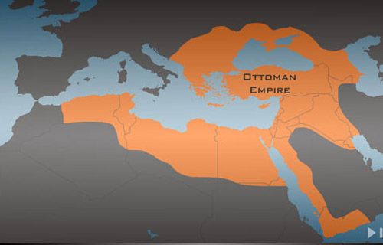

Imperial History of the Middle East: 5000 Years of History in 90 seconds
(actually, 3 minutes)

When you watch the presentation “Imperial History of the Middle East: 5000 Years of History in 90 seconds” pay special attention to what is happening within the borders of modern-day Europe. (It’s short—135 seconds (things are not always as advertised). ISIS (Islamic State of Iraq and al-Sham) declared itself a “Caliphate” 29 June 2014 under the name under the name "Islamic State". The U.S.A. and its allies, and Russia and their allies, continue the militaristic imperial history (sometimes through “proxies”), extending the 3000-year-old-pattern.

In short, it is difficult to understand much of modern-day Europe, and modern-day Europeans, without understanding the earlier historical influences of the various Arab groups. You have already begun to see that in the Greek villages.

So we’ll continue to have a look at the historical framework for the course by looking at one of the early major influences in many parts of Europe (and beyond)—Ottoman, Moorish, and other Turkish Empires. Arabs controlled much of the Iberian Peninsula (Spain, Portugal, Andorra, Gibraltar, and part of France) starting in the 8th century (A.D. 711) and ending just as Columbus was “discovering” America in 1492.

With a strong presence in Europe of almost 800 years, the Arabs had a considerable influence in the Mediterranean in general and the Iberian Peninsula in particular. Even after the Reconquista of Spain and the other countries the Ottomans exerted considerable influence over, including Sicily, much of the Arab influence in the eastern Mediterranean and Southeastern Europe continued.

That influence continues through the present-day. And influence from that neck of the woods may become stronger if/when Turkey is admitted to the EU.

(optional) For Fun
Take the Turkey Test!
from BBC News
[click ↑ here]

(Turkey slides)

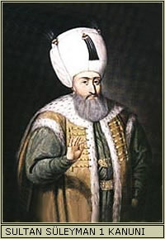
Süleyman the Lawgiver
aka
Süleyman the Magnificient
1494 - 1566

You do not need to post anything to your Canvas folder with the Turkey Test.

(optional) EXTRA CREDIT . . .
Basic Extra Credit Information

Extra Credit is available in this class.
We’ll have a closer look at Extra Credit after the Midterm Exam.

Be sure to check the details of the activities and assignments each week in your folder.

FOR FUN TRIVIA (optional)
Food Trivia HomePage

[click ↑ here]

Answer

LIVE CHAT OPEN FORUM / OFFICE HOURS . . . (optional)
Tuesday 7:00-8:00 p.m. (CDT) On ZOOM
Contact Information
“ZOOM”
[click ↑ here]
or
e-mail anytime: mailto:troufs@d.umn.edu
[click ↑ here]

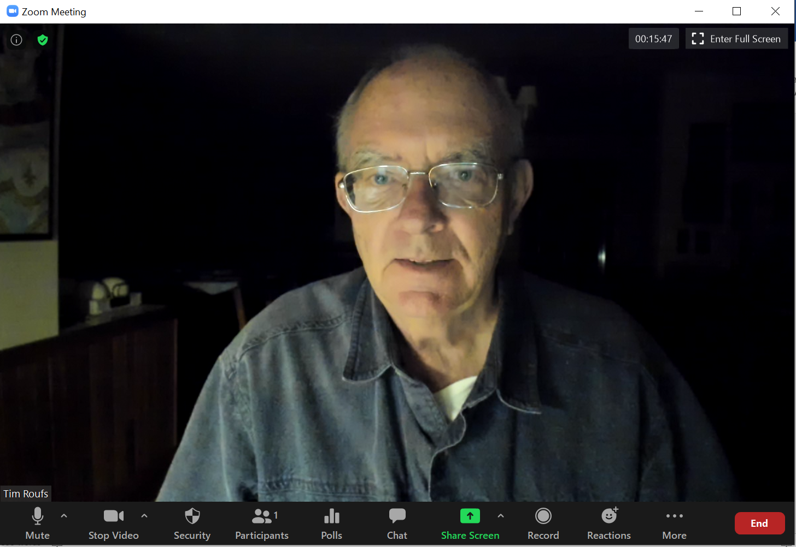

Live Chat is optional.

QUESTIONS? / COMMENTS / SUGGESTIONS . . .

If you have any questions or comments right now, please do not hesitate to post them on the “Discussions”, or e-mail troufs@d.umn.edu, or ZOOM https://umn.zoom.us/my/troufs. (E-mail is fastest, and most generally best as quite often URLs need be sent.)

Best Wishes,

Tim Roufs

<http://www.d.umn.edu/~troufs/>
<https://umn.zoom.us/my/troufs>
<other contact information>

